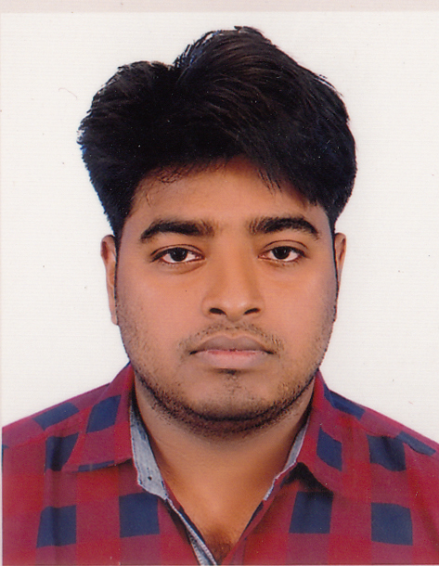
Curriculum Vitae
Utpal Kumar Basak
Mailing address : Vill: Sutulia, Post: Hatgopalpur,
P.S: Jhenaidah Sadar, Dist: Jhenaidah
Mobile No : 01915-102118
Email : utpalkumarbasak@gmail.com

Career Objective

In the beginning of career I’m highly desired to work in a reputed organization where I shall be able to explore my capabilities and gradually develop knowledge, skill and abilities to perform duties and responsibilities efficiently and effectively to add values to your organizations where I will find ample scope and opportunity to work and to promote to a significant position.

Educational Information

Bachelor of Arts(B.S.S honors)
- Name of the Institute : Jessore Cantonment College,Jessore
- University : National University
- Passing Year : 2015
- Major Subject : Political Science
- Result : CGPA-2.98
Higher Secondary Certificate (H.S.C)
- Name of the Institute : Raicharan Tarini Charan College(116553)
- Board : Jessore
- Group : Humanities
- Passing year : 2011
- GPA : 3.90
Secondary School Certificate (S.S.C)
- Name of the Institute : Hat Gopalpur Secondary School, Jhenaidah
- Board : Jessore
- Group : Humanities
- Passing year : 2009
- GPA : 3.13

Computer Knowledge

Participating and successfully completing six month courses on Introduction to Computer, Operating system with Windows, Word Processing with MS Word, Spread Sheet Analysis with MS Excel, MS Access, MS PowerPoint, Database Programming(Airnet Computer & Training Center, Jessore)

Interest/Hobby

Reading Books, Newspaper & Listening Music, Social Well Fare, Internet Browsing.

Language Proficiency
Bengali : Speaking, Reading and Writing (Well)
English : Speaking Reading and Writing. (Well)
It Skills:
- Well acquainted with MS office package.
- Adequate Knowledge on E-mailing and internet.
- Fundamental Knowledge on other necessary programs.
Other Skills:
- Leadership skill
- Presentation skill.
- Self motivation capability
- General communication skill.
- Language skill (Both English and Bengali reading/writing/speaking ability).
- Successfully participated in the Orientation on “excommunicating information to the people
Personal Information
- Name : Utpal Kumar Basak
- Father’s Name : Gurudas Basak
- Mother’s Name : Panchami Rani Basak
Permanent Address : Vill: Sutulia, Post: Hatgopalpur,
P.S: Jhenaidah Sadar, Dist: Jhenaidah

- Date of birth : 25th December 1991
- Nationality : Bangladeshi (By Birth)
- Religion : Hindu
- Marital Status : Unmarried
- Sex : Male
- National Id No : 19914411931000090
- Blood Group : O+



…..........................
Signature & Date:
Utpal Kumar Basak

